Weather Data Pipeline using AWS and Snowflake

Introduction
The Weather Data Pipeline using AWS and Snowflake is a serverless data engineering project that automates the collection, processing, storage, and analysis of real-time weather data. The project uses the OpenWeather API to fetch weather information for multiple cities, including temperature, humidity, weather conditions, and other related details.
The data is collected through AWS Lambda and stored in Amazon DynamoDB. It is then processed in Amazon S3, where unwanted fields, duplicate records, and null values are removed to improve data quality. The cleaned data is automatically loaded into Snowflake using Snowpipe for efficient storage and analysis. Finally, the data is retrieved from Snowflake and visualized in Visual Studio Code using Python libraries such as Pandas and Matplotlib, providing meaningful insights through charts and graphs.
This project demonstrates an end-to-end cloud-based data pipeline using AWS services and Snowflake for automated data ingestion, processing, and visualization.
Architecture
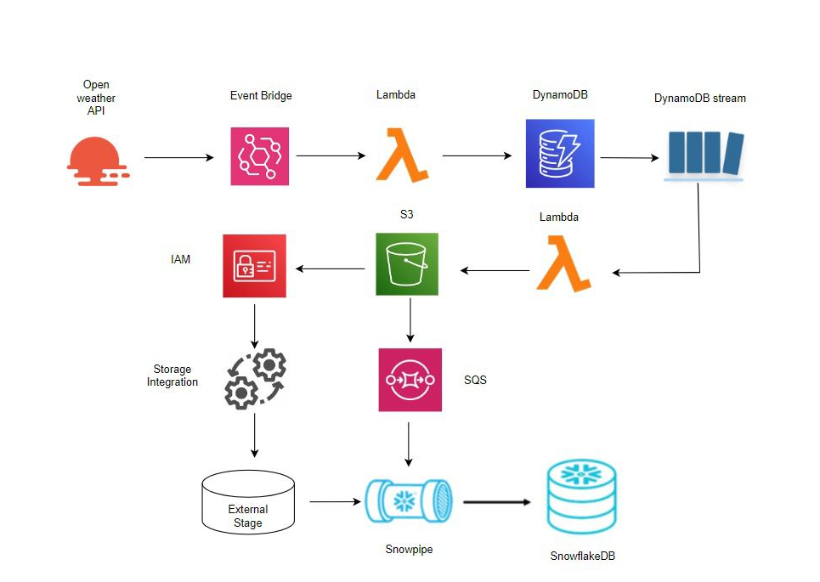

Step 1: Open Weather API
The pipeline begins by collecting live weather information from the OpenWeather API. An API key is generated from the OpenWeather website, which authenticates the request and allows access to current weather data.
The Lambda function sends an HTTP request to the API, specifying the required city names (such as Kochi, Mumbai, Chennai, Delhi, and Bangalore). The API returns the weather information in JSON format.
The response includes:
- City Name
- Temperature
- Humidity
- Country
- Date and Time

Step 2: Amazon EventBridge
Amazon EventBridge is used to automate the execution of the weather data collection process.
A scheduled rule is created to trigger the Lambda function at regular intervals (for example, every 5 minutes). This ensures that the latest weather information is collected automatically without requiring manual execution.

Purpose
- Automates data collection.
- Runs the pipeline on a fixed schedule.
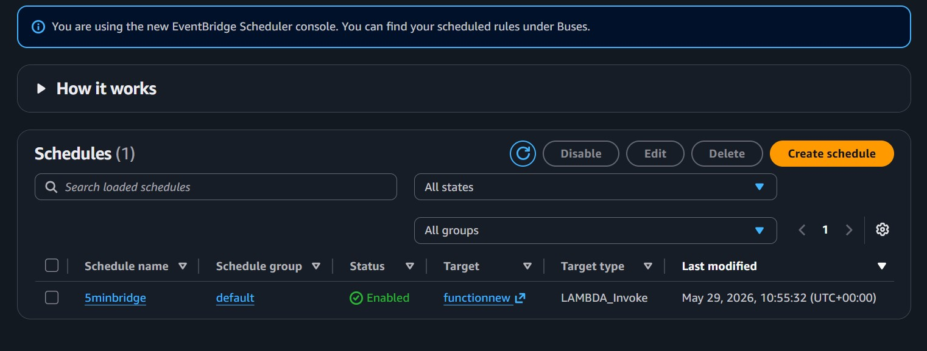

Step 3: AWS Lambda (Weather Data Collection)
AWS Lambda is a serverless compute service that executes Python code without requiring a dedicated server.
When EventBridge triggers the function, the Lambda function performs the following tasks:
- Connects to the OpenWeather API.
- Sends a request using the API key.
- Receives the JSON response.
- Extracts the required weather details.
- Formats the data.
- Inserts the data into Amazon DynamoDB.

Purpose
- Fetch real-time weather information.
- Process API response.
- Store structured weather data.
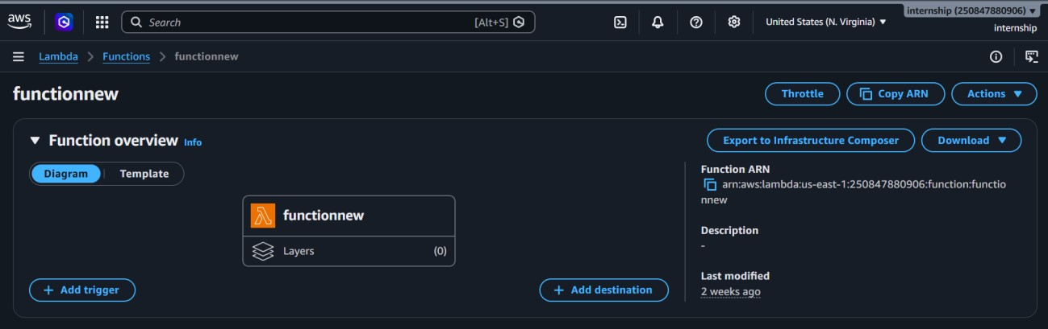
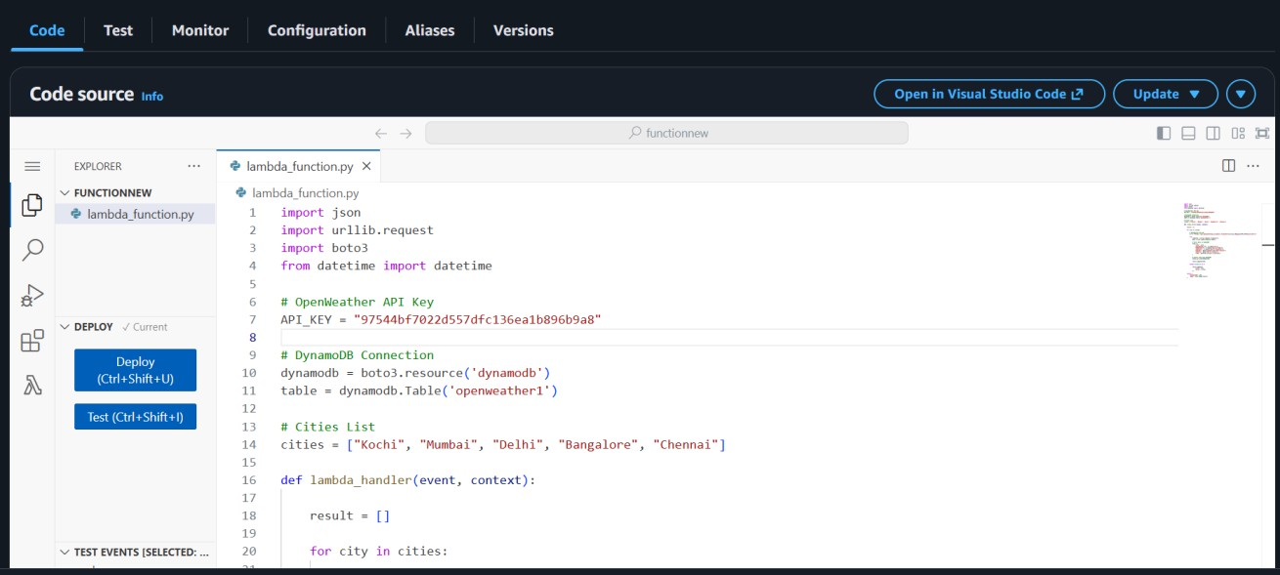

Step 4: Amazon DynamoDB
Amazon DynamoDB is used as the primary storage database for the weather data.
Each weather record is stored as a separate item in the DynamoDB table. Every time the Lambda function executes, a new record is inserted into the table.
The table contains fields such as:

Attribute Description
City Name of the city
Temperature Current temperature
Humidity Humidity percentage
Weather Weather condition
Timestamp Date and time of data collection

Purpose
- Store weather data.
- Provide fast read and write operations.
- Act as the source for downstream processing.

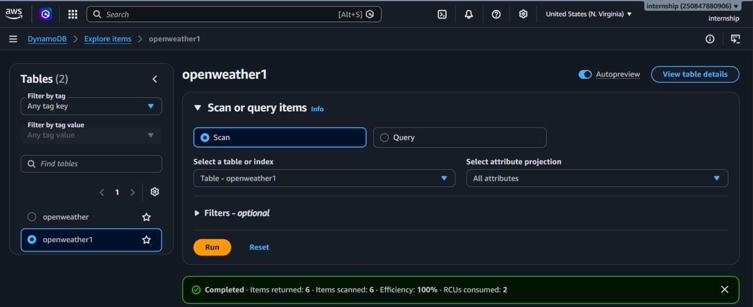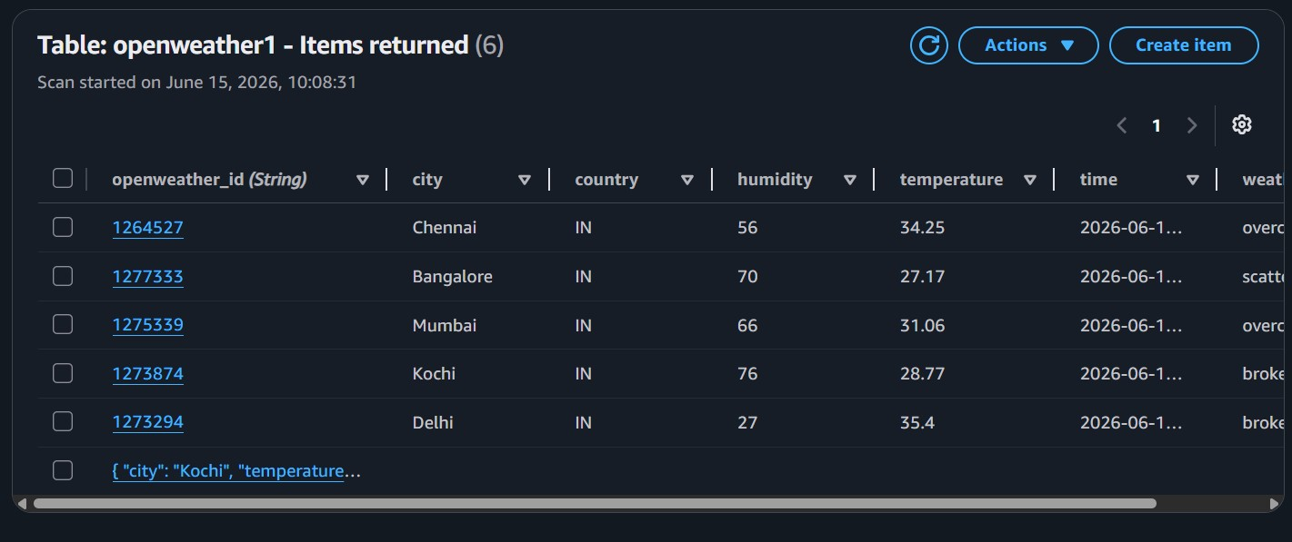

Step 5: DynamoDB Streams
DynamoDB Streams continuously monitor changes made to the DynamoDB table.
Whenever a new weather record is inserted, DynamoDB Streams captures the event and automatically invokes another Lambda function.
This allows newly added records to be processed in near real time.

Purpose
- Detect new records.
- Trigger the next stage automatically.
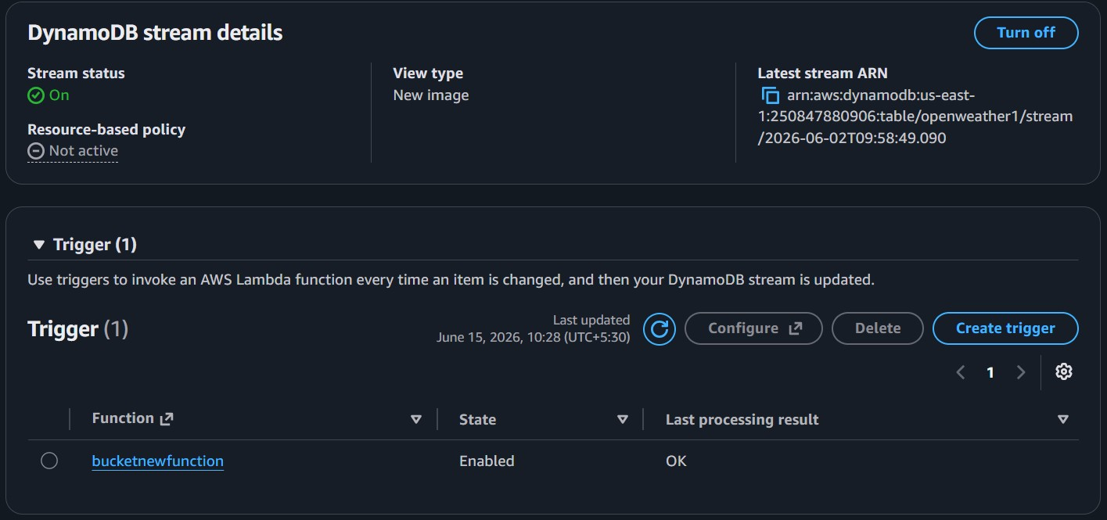
•

Enable event
-
driven processing.

Step 6: AWS Lambda (Data Processing)
The second Lambda function receives the new weather record from DynamoDB Streams.
Before storing the data in Amazon S3, it performs data preprocessing to improve data quality.
The processing includes:
- Removing duplicate records.
- Removing null or empty values.
- Removing unwanted fields from the API response.
- Keeping only useful weather attributes.
After cleaning, the data is converted into JSON format.

Purpose
- Improve data quality.
- Reduce unnecessary storage.
- Prepare clean data for analytics.
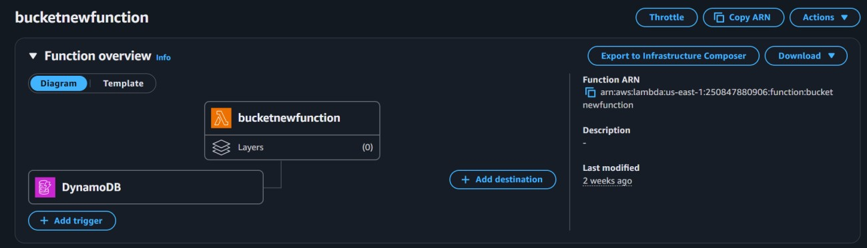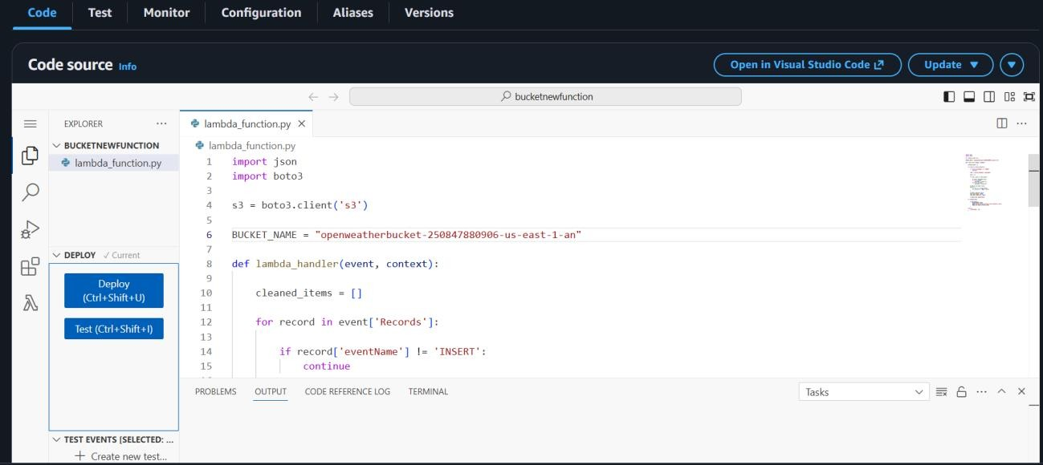

Step 7: Amazon S3
Amazon S3 acts as the staging area for cleaned weather data.
The processed JSON files are stored inside the S3 bucket. Since the data has already been cleaned, Snowflake receives only high-quality records.

Purpose
- Store cleaned data.
- Remove duplicate and null records.
- Act as the source for Snowflake.
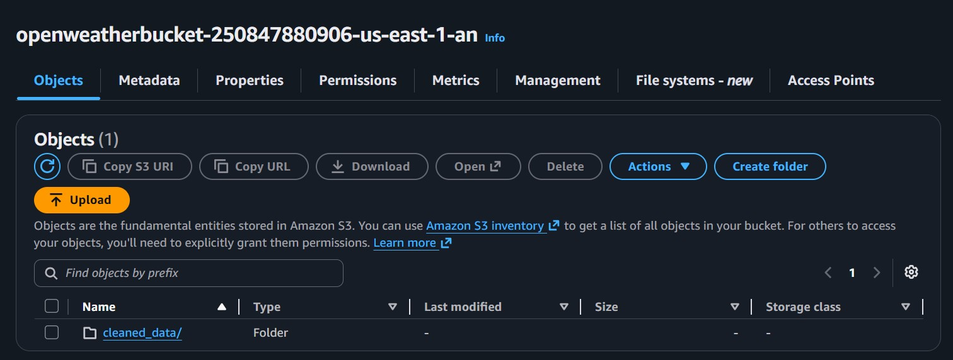

Step 8: IAM Role and Snowflake Storage Integration
To allow Snowflake to access the S3 bucket securely, an AWS IAM Role is created.
A Snowflake Storage Integration is then configured using the IAM Role.
This enables Snowflake to read files from Amazon S3 without storing AWS access keys.

Purpose
- Secure connection between AWS and Snowflake.
- Avoid exposing AWS credentials.
- Enable secure file access.
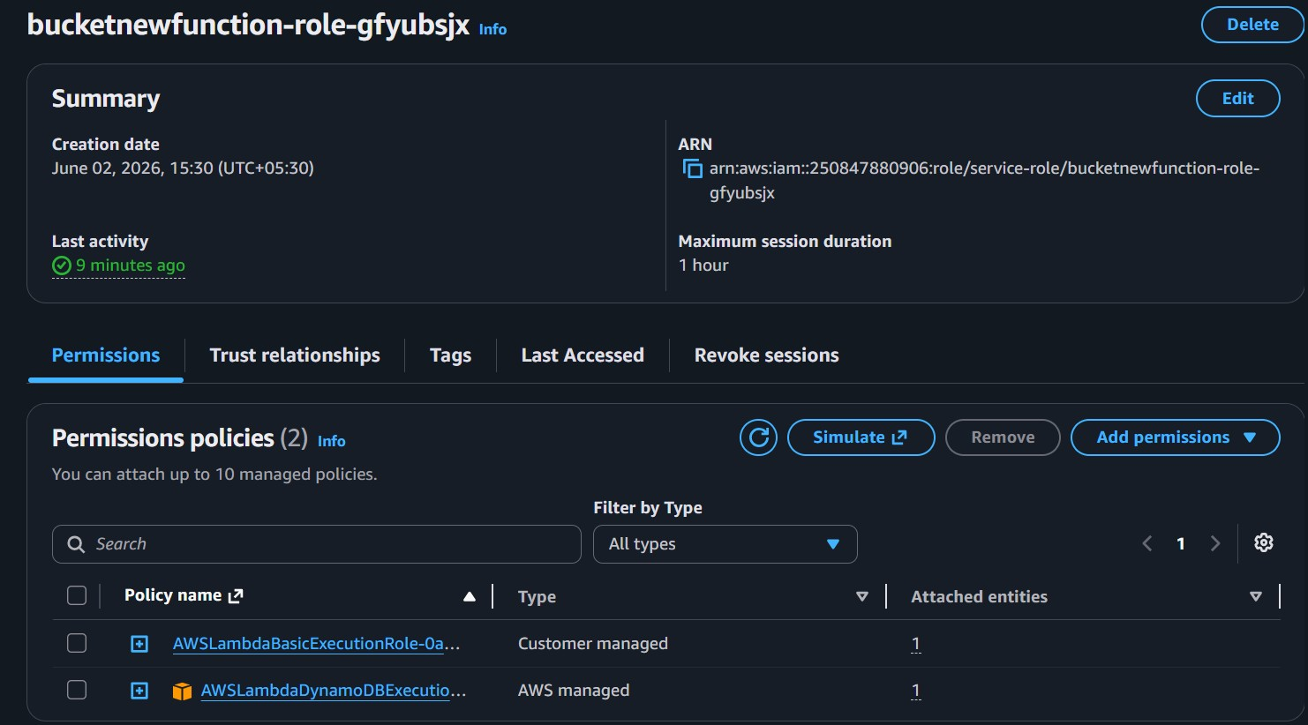

Step 9: Amazon SQS
Whenever a new JSON file is uploaded to Amazon S3, S3 generates an event notification.
The notification is sent to an Amazon SQS queue.
Snowpipe continuously monitors this queue for new file notifications.

Purpose
- Notify Snowpipe about newly uploaded files.
- Support automatic data ingestion.
- Eliminate manual file loading.
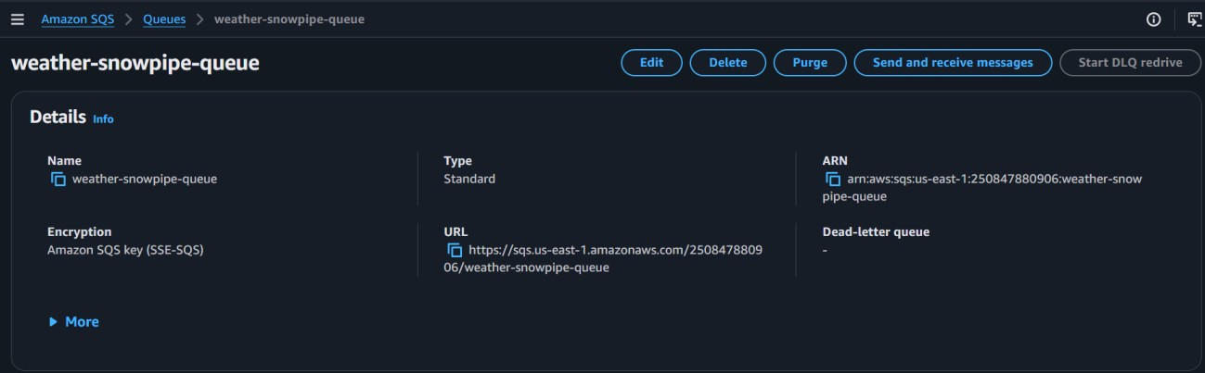

Step 10: Snowpipe
Snowpipe is Snowflake's continuous data ingestion service.
When it receives a notification from Amazon SQS, it automatically detects the new JSON file stored in Amazon S3.
Snowpipe executes the COPY INTO operation internally and loads the cleaned data into a Snowflake table.
No manual import is required.

Purpose
• Automatically load data. • Reduce processing time.
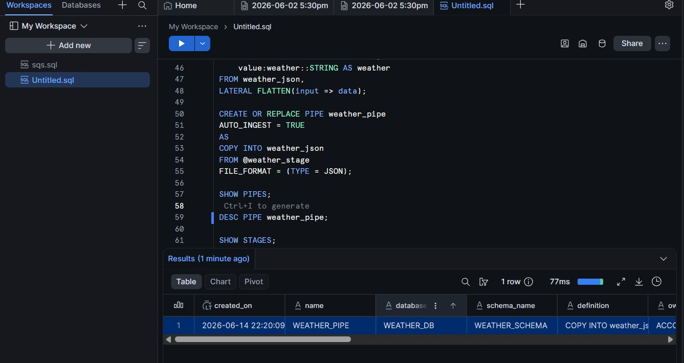
•

Support near real
-
time analytics.

Step 11: Snowflake Database
Snowflake is the final destination for the processed weather data.
The cleaned records are stored in a structured table, where SQL queries can be used for analysis and reporting.
Example analyses include:
- Average temperature by city.
- Highest humidity.
- Weather condition trends.
- Daily weather reports.
- Dashboard creation using BI tools.

Purpose
- Store analytical data.
- Enable SQL querying.
- Support reporting and visualization.
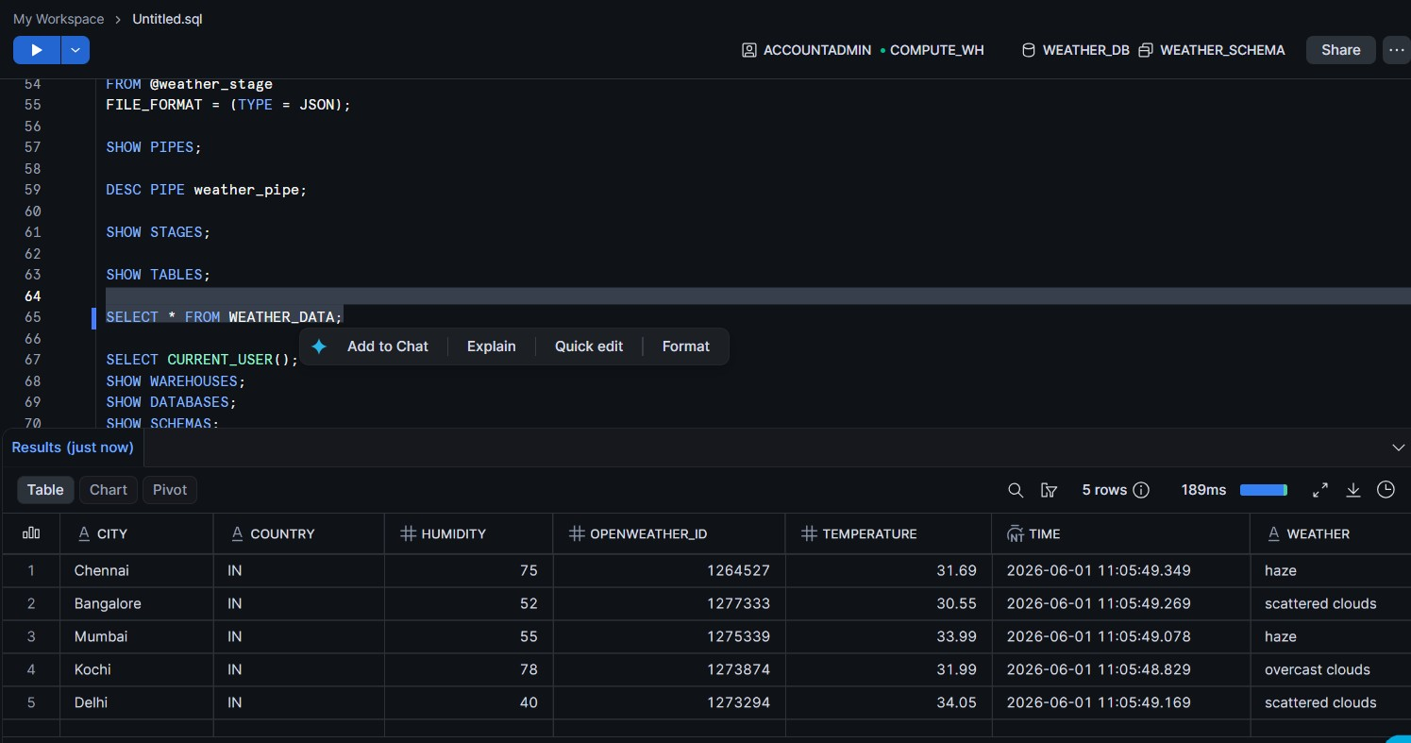

Step 12: Data Visualization in Visual Studio Code
After the cleaned weather data is successfully loaded into the Snowflake database, a Python script is executed in Visual Studio Code (VS Code) to retrieve the data from Snowflake and visualize it using graphs.
The Python script establishes a connection to the Snowflake database using the Snowflake Python Connector. It then executes SQL queries to fetch the required weather data and loads the results into a Pandas DataFrame. Finally, the data is visualized using the Matplotlib library, enabling easy analysis of weather trends.
The graphs provide a clear representation of weather information, making it easier to identify patterns and compare weather conditions across different cities.

Purpose
- Retrieve processed data from Snowflake.
- Perform data analysis using Python.
- Visualize weather data through charts and graphs.
- Simplify the interpretation of weather trends.
- Support reporting and presentation of project results.
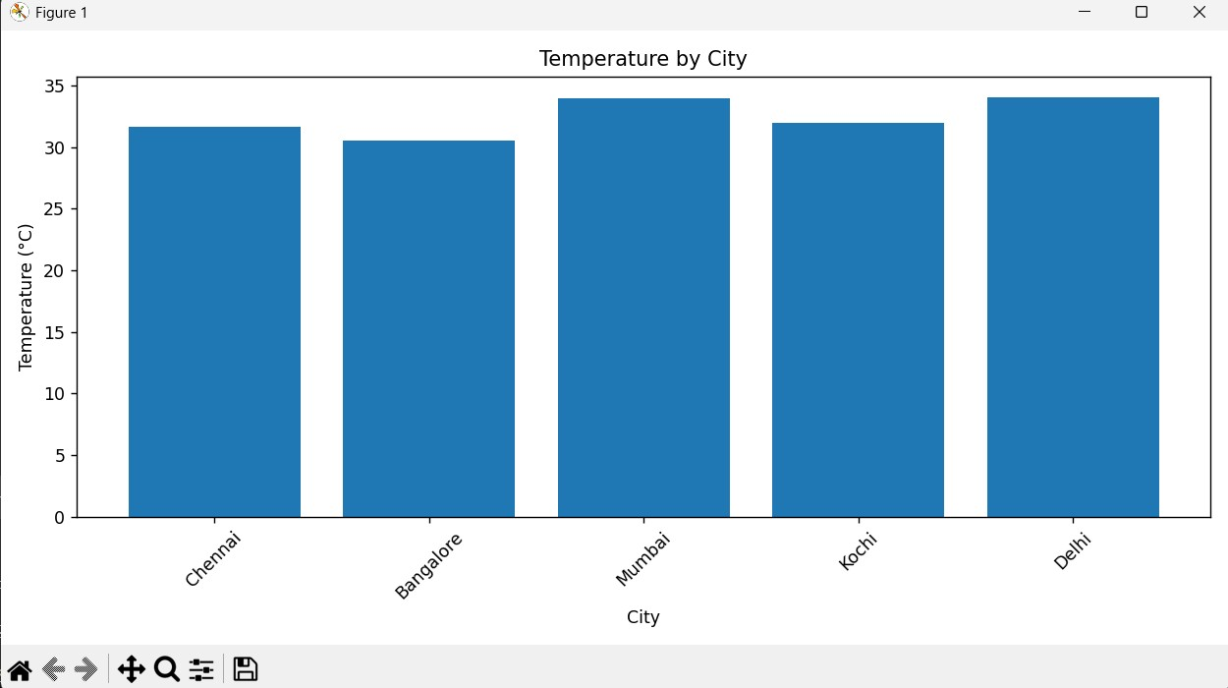
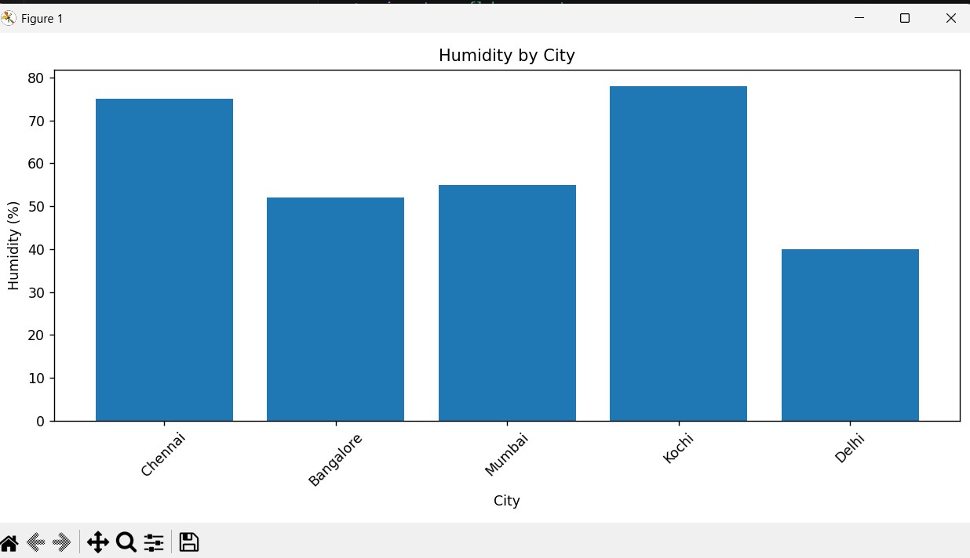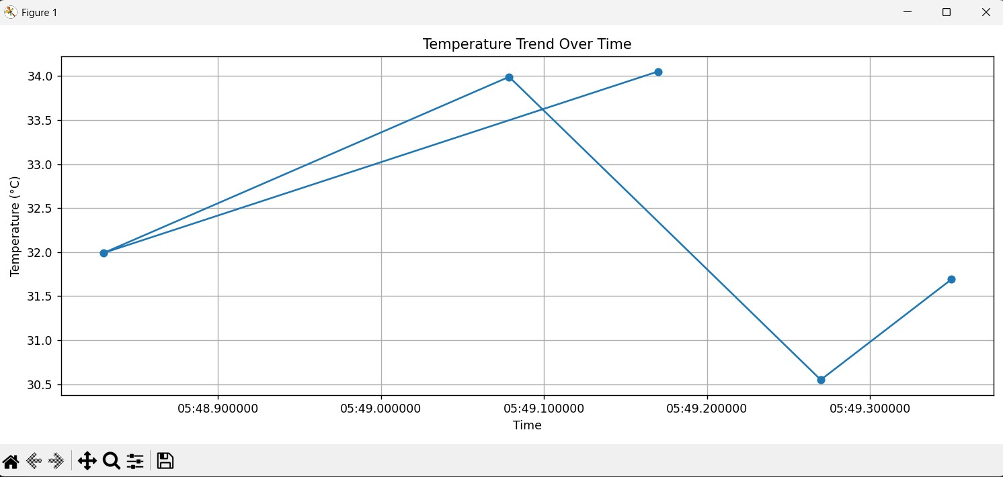
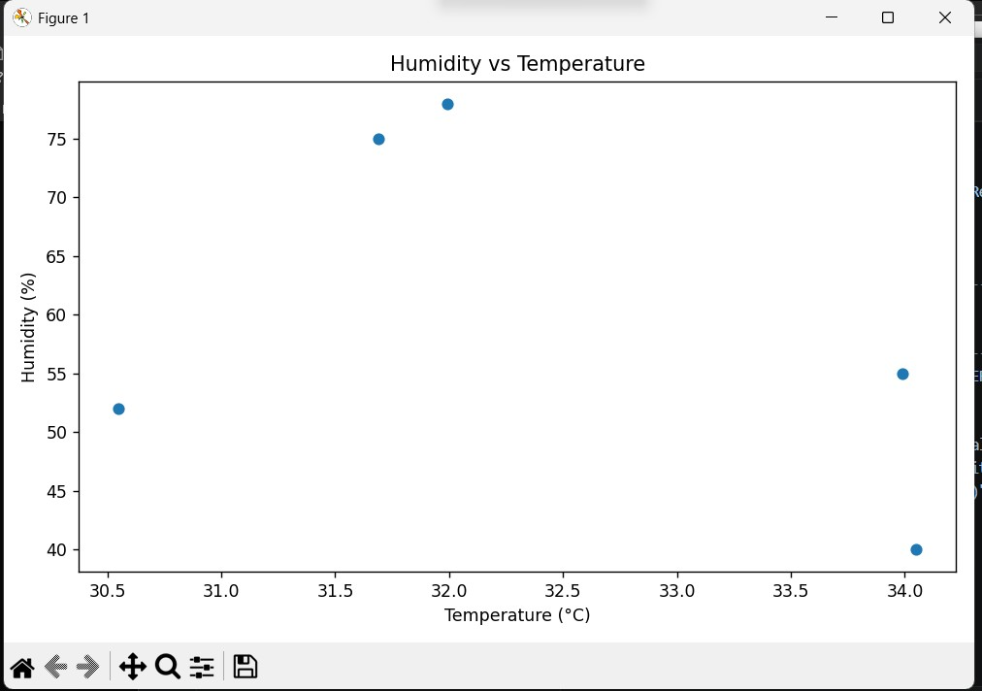

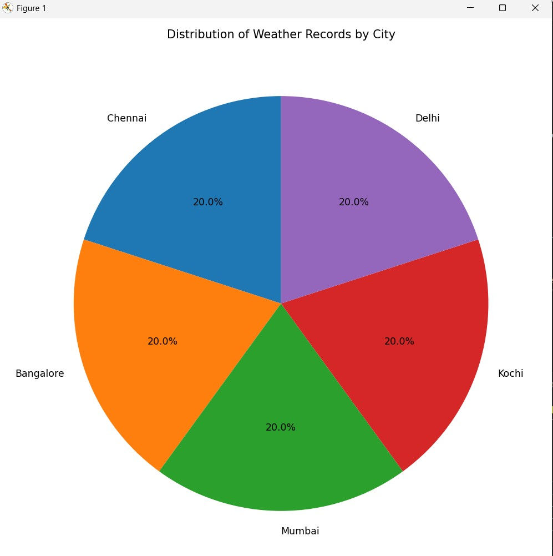

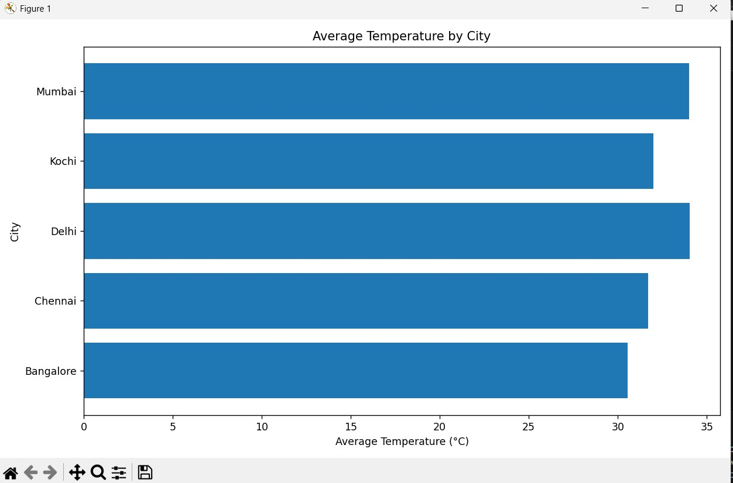

Data Flow Summary
OpenWeather API
│
▼
Amazon EventBridge
│
▼
AWS Lambda
(Fetch Weather Data)
│
▼
Amazon DynamoDB
│
▼
DynamoDB Streams
│
▼
AWS Lambda
(Data Cleaning)
│
▼
Amazon S3
(Cleaned JSON Files)
│
▼
Amazon SQS
│
▼
Snowpipe
│
▼
Snowflake Database

